HOSPITAL BED SCHEDULING SYSTEM
(Type your project title here)
ProjectReportsubmitted forthepartialfulfilmentof grade for the course

Data Structures and Algorithms -3 (25CS2103E)
in

A.Y. 2026-2027

Submittedby
Srija (2520090053)
Keerthana (2520090132)

Team Number: 23
Section: 12

Undertheguidanceof

<<DR.Chandusha>>

<<Designation, Department>>
Hyderabad-500090,Telangana,India.

K L (Deemed to be) University
DEPARTMENT OFCOMPUTER SCIENCE ENGINEERING / COMPUTER SCIENCE AND INFORMATION TECHNOLOGY/ARTIFICIAL INTELLIGENCE & DATA SCIENCE



DECLARATION

The Mini Project Report entitled “Hospital Bed Scheduling System” is a record of Bonafide work of Srija – 2520090053, Keerthana – 2520090132, submitted in partial fulfillment for the award of B. Tech in Computer Science and Engineering / Computer Science and Information Technology / Artificial Intelligence & Data Science to the K L University. The results embodied in this report have not been copied from any other departments/University/Institute.

Srija - 2520090053
Keerthana - 2520090132

K L (Deemed to be) University
DEPARTMENT OF COMPUTER SCIENCE ENGINEERING / COMPUTER SCIENCE AND INFORMATION TECHNOLOGY
CERTIFICATE

This is to certify that the mini project based report entitled “Hospital Bed Scheduling System “ is a bonafide work done and submitted by P.Srija - 2520090053, Keerthana – 2520090132 ., .in partial fulfillment of the requirements for the award of the degree of BACHELOR OF TECHNOLOGY in Department of Computer Science Engineering/Computer Science and Information Technology/Artificial Intelligence & Data Science, K L (Deemed to be University), during the academic year 2026-2027.

Signature of the Supervisor

Signature of the HOD Signature of the External Examiner

ACKNOWLEDGEMENT

The success in this project would not have been possible but for the timely help and guidance rendered by many people. Our wish to express my sincere thanks to all those who has assisted us in one way or the other for the completion of my project.

Our greatest appreciation to my guide,<<Guide Name>>, <<Designation>>, <Department>>which cannot be expressed in words for his/her tremendous support, encouragement and guidance for this project.

We express our gratitude toDr. P.Venkateshwar Rao (CSE)/Dr. KhajaShareef(CSIT)/ Dr. SreenathItikela (AI&DS), Head of the Department for Computer Science Engineering/ Department for Computer Science and Information Technology/Department of Artificial Intelligence and Data Science for providing us with adequate facilities, ways and means by which we are able to complete this project-based Lab.

We thank all the members of teaching and non-teaching staff members, and also who have assisted me directly or indirectly for successful completion of this project. Finally, I sincerely thank my parents, friends and classmates for their kind help and cooperation during my work.

Srija - 2520090053
Keerthana - 2520090132

TABLE OF CONTENTS

S.No. | Contents | Page no.
1. | Abstract
2. | Introduction
3. | Literature survey
4. | Problem Statement and Objectives
5. | Hardware and Software requirements
6. | Implementation
7. | Results& Discussion
8. | Conclusion& Future Scope
9. | References

1.ABSTRACT

Hospital Bed Scheduling System is an algorithm-based intelligent platform designed to efficiently manage and allocate hospital beds to patients based on their medical requirements, bed availability, priority, and department. The system aims to reduce waiting time, avoid unnecessary bed conflicts, and improve the overall utilization of hospital resources. It uses algorithmic scheduling techniques to assign suitable beds to patients while considering factors such as emergency priority, ward type, patient requirements, and availability. The system provides an organized approach for hospital staff to monitor available, occupied, and reserved beds. By automating the bed allocation process, the proposed system minimizes manual effort and helps healthcare administrators make faster and more effective decisions. The system can improve patient flow, reduce delays in admissions, and ensure better utilization of available hospital infrastructure. Overall, the Hospital Bed Scheduling System provides a smart and systematic solution for efficient hospital bed management.
Team Name:
BedSmart

Team Logo (if any):

Team Members:
- [Srija, 2520090053]
- [Keerthana, 2520090132]

- INTRODUCTION

Hospitals often face challenges in managing and allocating beds efficiently, especially when there are emergencies, high patient admissions, or limited bed availability. Manual bed allocation can lead to delays, scheduling conflicts, and inefficient utilization of hospital resources.
The Hospital Bed Scheduling System is an algorithm-based intelligent platform designed to automate and optimize the process of assigning hospital beds to patients. The system considers factors such as patient priority, medical requirements, bed availability, ward type, and emergency conditions while scheduling beds.
The main objective of this project is to reduce patient waiting time, avoid bed allocation conflicts, and improve the utilization of available hospital beds. By using suitable scheduling algorithms, hospital staff can quickly identify available beds and assign them to patients according to their priority and requirements.
This system provides a systematic and efficient approach to hospital bed management and can help improve patient flow, resource utilization, and the overall efficiency of hospital operations.

- LITERATURE SURVEY
- Automated Bed Management: Uses algorithms and machine learning to manage hospital bed availability and improve resource utilization.
- Genetic Algorithm for Bed Allocation: Optimization algorithms are used to assign beds efficiently based on patient requirements and availability.
- Simulation-Based Bed Allocation: Simulation techniques help hospitals predict demand and optimize bed capacity.
- Patient Bed Assignment: Optimization methods assign suitable beds while considering patient needs and bed characteristics.
- Real-Time Bed Management: Modern systems track available, occupied, reserved, and cleaning beds to support quick decisions.

- Problem Statement and Objectives

Problem Statement: Efficiently allocate hospital beds to patients based on availability, priority, and medical requirements.

Problem Description: Manual bed allocation can cause delays, conflicts, and inefficient use of available beds. The system aims to automate and simplify the bed scheduling process

Objectives:
- Efficient Bed Allocation: Assign suitable beds based on patient requirements.
- Reduce Waiting Time: Quickly identify and allocate available beds.
- Priority Management: Give priority to emergency and critical patients.
- Avoid Conflicts: Prevent double booking and scheduling errors.
- Improve Resource Utilization: Make better use of available hospital beds.

- HARDWARE AND SOFTWARE REQUIREMENTS

Hardware Requirements:
- Processor: Intel Core i3 or above
- RAM: 4 GB or above
- Storage: 10 GB free space

Software Requirements:
- Operating System: Windows 10/11
- Frontend: HTML, CSS, JavaScript
- Backend: Java / Python
- Database: MySQL
- IDE: VS Code / IntelliJ IDEA
- Browser: Google Chrome

- IMPLEMENTATION

MODULE 1: Pateint Management
class Patient {
int id;
String name;
String requirement;
int priority;

Patient(int id, String name, String requirement, int priority) {
this.id = id;
this.name = name;
this.requirement = requirement;
this.priority = priority;
}

void display() {
System.out.println("Patient ID: " + id);
System.out.println("Name: " + name);
System.out.println("Requirement: " + requirement);
System.out.println("Priority: " + priority);
}
}

Module 2: Bed Management
class Bed {
int bedId;
boolean occupied;

Bed(int bedId) {
this.bedId = bedId;
this.occupied = false;
}

void displayStatus() {
String status = occupied ? "Occupied" : "Available";
System.out.println("Bed " + bedId + ": " + status);
}
}

Module 3: Bed Scheduling & Allocation
class BedScheduler {
static void allocateBed(Patient p, Bed b) {
if (!b.occupied) {
b.occupied = true;
System.out.println("Bed " + b.bedId +
" allocated to " + p.name);
} else {
System.out.println("Bed is already occupied.");
}
}
}

Module 4: Admin Dashboard
public class HospitalBedSystem {
public static void main(String[] args) {

Patient p1 = new Patient(
101, "Srija", "General Ward", 1
);
Bed b1 = new Bed(1);
System.out.println("=== ADMIN DASHBOARD ===");
p1.display();
b1.displayStatus();
BedScheduler.allocateBed(p1, b1);
System.out.println("\nUpdated Bed Status:");
b1.displayStatus();
}
}
- RESULTS& DISCUSSION
Output application run screen shots with their explanation in 2 lines.
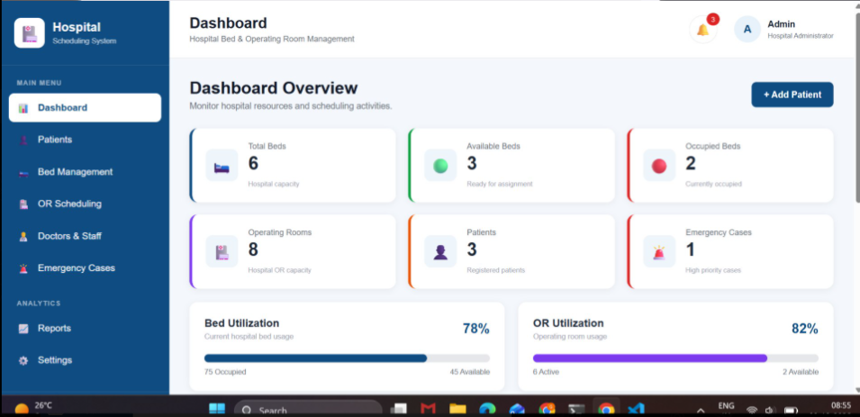
The Patient Management page allows the admin to register, search, and manage patient details, including department, priority, bed, and admission status.

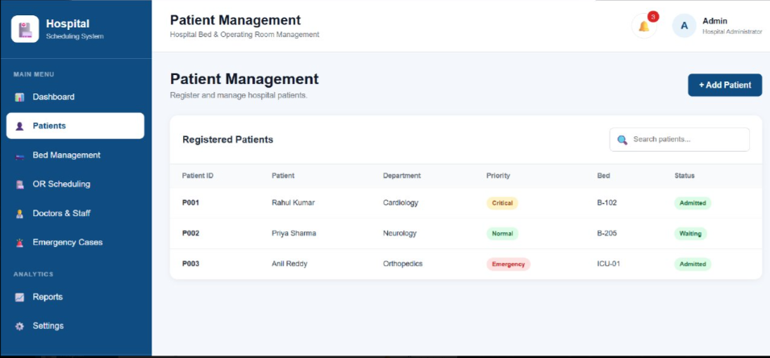
The Dashboard provides an overview of total, available, and occupied beds, patients, operating rooms, emergency cases, and overall resource utilization
- CONCLUSION&FUTURE SCOPE

Conclusion
- The Hospital Bed Scheduling System provides an efficient way to manage and allocate hospital beds.
- It reduces waiting time, scheduling conflicts, and manual effort.
- The system improves bed utilization and patient management.
- Priority-based allocation helps ensure critical patients receive beds quickly.

Future Scope
- AI/ML-based bed demand prediction.
- Real-time bed availability tracking.
- Mobile application for hospital staff.
- Integration with existing Hospital Management Systems.

- REFERENCES

References
- W3Schools – Web Development
- GeeksforGeeks – Algorithms & Data Structures
- MDN Web Docs – JavaScript
- MySQL Documentation – Database
- NHS England – Hospital Bed Management
- Google Search – Existing Bed Scheduling Systems

